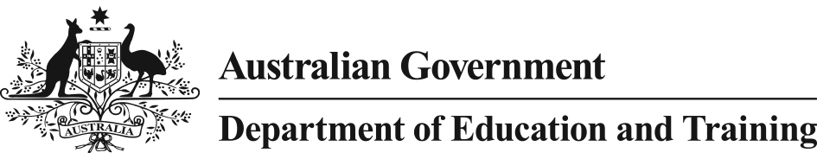

2017 Student Residential Address Collection
This notice is from the Australian Government Department of Education and Training (the department), to advise you that the department has requested your child’s school provide a statement of addresses, in accordance with section 21 of the Australian Education Regulation 2013 (the Regulation).
A statement of addresses contains the following three pieces of information about students at the school:
- Students’ residential address (not student names or other identifying information)
- Students’ level of education (i.e. whether the student is receiving primary or secondary education)
- Students’ boarding school status (boarders or day students)
Authority for and Purpose of Collection
Consistent with previous practice, and following the 2016 Australian Bureau of Statistics National Census of Population and Housing (Census), it is timely that information held by the department is updated in order to ensure that Australian Government funding calculations for your child’s school are accurate.
Under section 21 of the Regulation, a statement of addresses must not explicitly identify an individual student. Accordingly, all information in the statement of addresses provided by your child’s school to the department is de-identified.
Use and Disclosure of Information
It is important to ensure the statements of addresses are accurate, and the department may from time to time carry out audits of statements of addresses to verify their accuracy. In the event of an audit, the department’s contracted auditors may seek to compare a school’s statement of addresses with student enrolment information held by the school for the purpose of verifying the information. The department’s contractors will not use the information for any other purpose.
Any further use and disclosure of information relating to the statement of addresses will occur in accordance with section 65 of the Regulation.
Contact
If you have any questions regarding this notice, you can contact the department by:
- Email: seshelpdesk@education.gov.au
- Phone (free call): SES helpdesk on 1800 677 027 (Option 4)
For further information about the department, including the department’s privacy policy, please go to: https://education.gov.au.

